## Overview

Your style guide is structurally sound, but it lacks color. In this activity, you will be using CSS to add color to your HTML elements.

## Tips

* Remember, you can edit CSS (and HTML) in your browser’s web inspector. Feel free to try out edits in the Web Inspector *before* working on your local files.
* Colors in HTML can be added using hex codes or keywords like blue or red. Read more about how to use and apply colors [here](https://developer.mozilla.org/en-US/docs/Web/CSS/background-color).

## Instructions

You will be adding a lot of styles to your file, and they will transform your style guide.

1. Download the Activities .zip from Google Drive located [here](https://drive.google.com/drive/u/1/folders/14P5qyO0xlhxdKPCE7TMpWQZuwABw6XWQ).
2. Open style.css.
   * It’s located in the Unit 17 Activities folder, inside **17.2_unsolved.zip**.
   * Remember to get in the habit of downloading the Activities .zip folder each day before class.
3. Add the following selectors and properties within the **Primary Color** section:

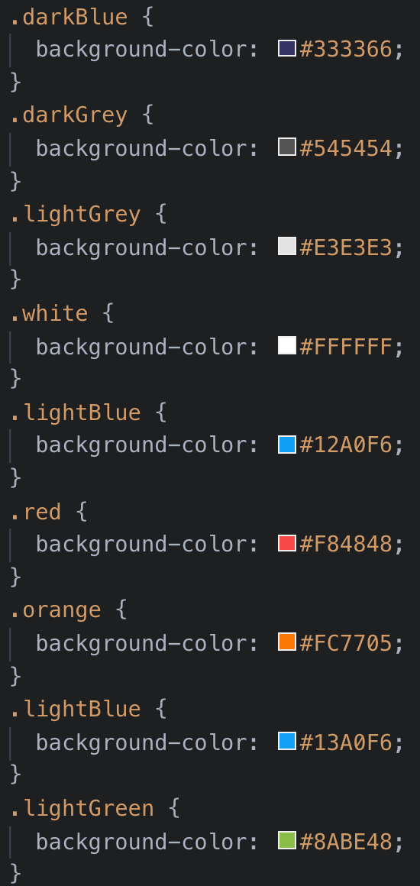

1. Add the following selectors and properties within the **UI Elements** section.

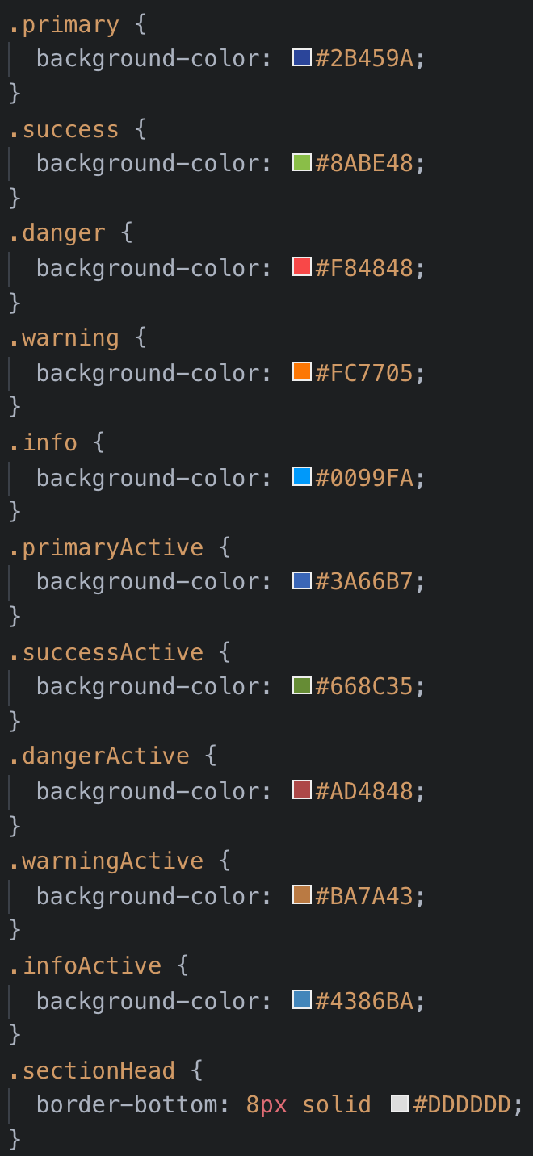

Note the “Before” and “After” style guide illustration below. Yours should look like the following:

5. Share a screenshot of your work via Slack.

|  | **⇨** |  |
| --- | --- | --- |